Shrew Retching Analysis

Video Recordings:

Single video on 10/19/2021 of 4 isolated shrews having received 5mg/ml/kg nicotine.

Video trimmed to 11 minutes: nicotine_emesis_10.19.21_all.mp4

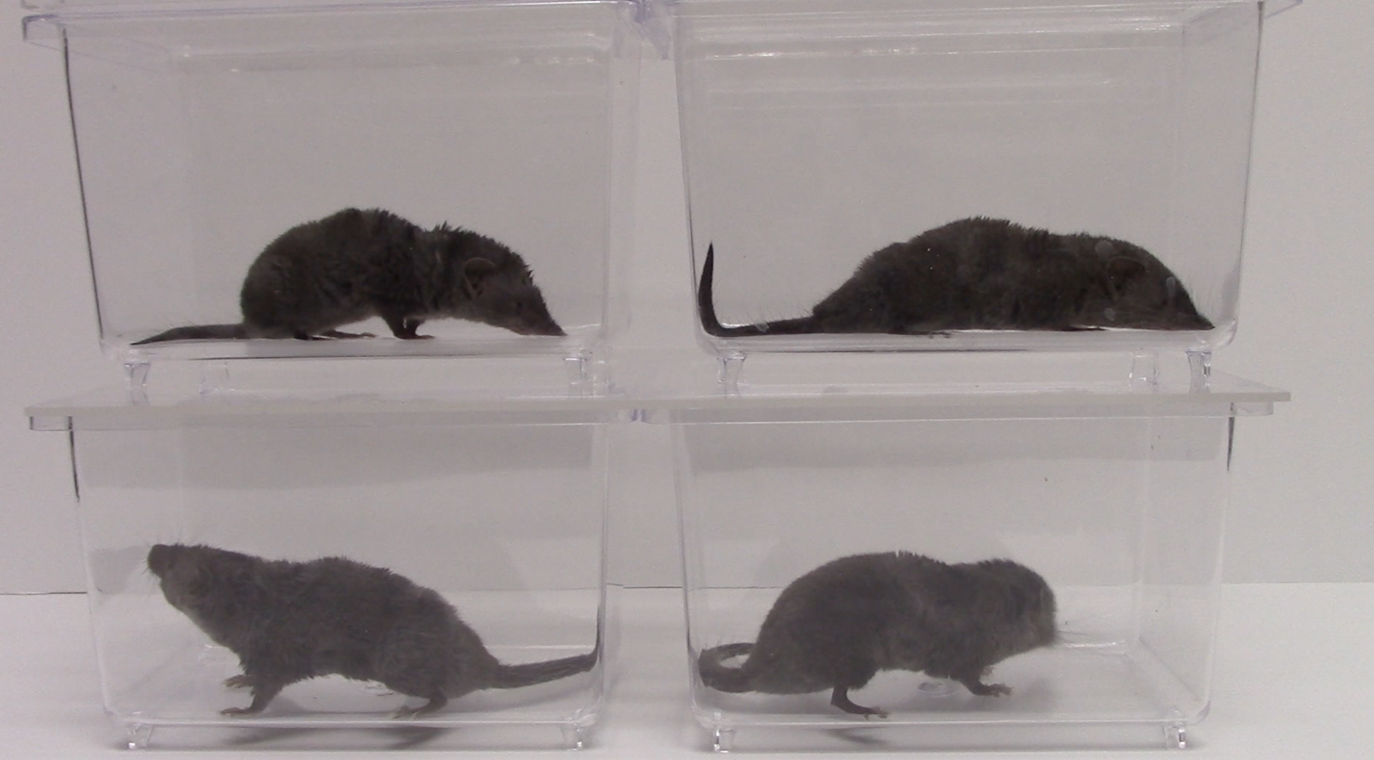

Shrew1

Shrew2

Shrew3

Shrew4

Each shrew cropped and saved for separate video (all trimmed starting at 5:11)

nicotine _10.19.21_shrew1.mp4

nicotine _10.19.21_shrew2.mp4

nicotine _10.19.21_shrew3.mp4

nicotine_10.19.21_shrew4.mp4

Animal Behavior Notes

* Shrew 1 retched the most
* Shrew 3 did not retch
* Shrew 2 and 4 snout slightly out of focus most of the time, facing back corner, both retched 1x
* Shrew 4 most active and yawned ~3 times (timestamp recorded as Y)

Watched videos and marked retching episodes as R in document shrew_retching_tracker.xlsx

**DEEPLAB CUTS**

***Frame extraction and labeling done on GUI***

Video clips cropped to only include behavior of interest retching

Only included shrew 1, 2, 4

Grabbed frames specified by g in shrew_retching_tracker.xslx

Labeling considerations

* Retching is a very rapid behavior, despite recording at 60fps many frames are blurry
  + If I label the frame, then the question is where in the movement
  + Unlabeled and then apply SARIMAX filtering to track

Trained on a 95:5 train:test split

ResNet50

50 CNN lauers

Input image size 224x224

Imgaug python

p-cutoff set to 0.9

filtering